Part 1:

Step 2:

1. 10.10.1.97
2. 10.10.1.17
3. 10.10.1.6
4. 10.10.1.4/30

10.10.1.6/32

1. 10.10.1.10

10.10.1.8/30

10.10.1.10/32

1. 10.10.1.2

10.10.1.9

Step 3:

The error is that R2 has serial0/0/0 assigned to 10.10.1.2 when it should be 10.10.1.5

To fix the problem we need to change the address to 10.10.1.5

Step 5:

1. 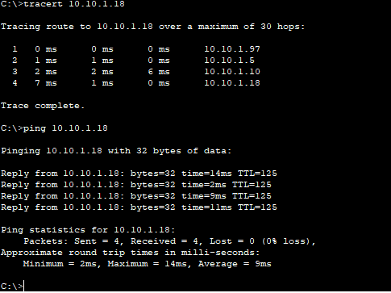
2. 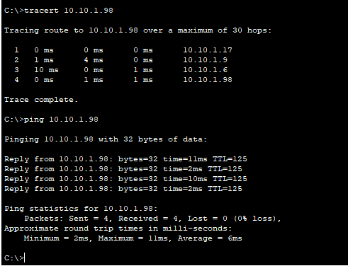

Step 6: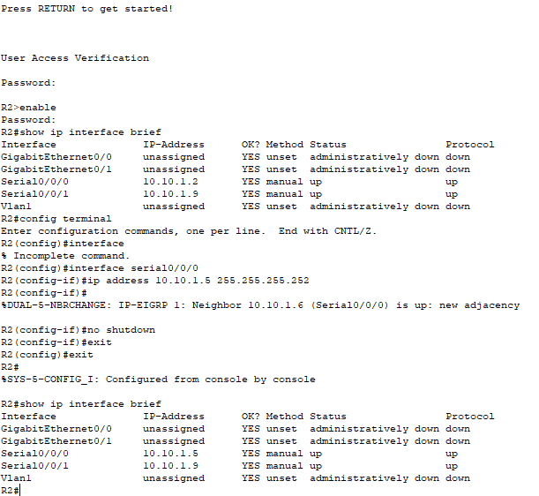

Part 2:

Step 2:

1. 2001:db8:1:3::2
2. N/A it doesn’t reach any
3. R3 shows fe80::3 and PC4 shows fe80::2

Step 3:

The default gateway on the R3 does not match the default gateway on PC4

Go into IP Configuration on PC4 and change the default gateway to f380::3

Step 5:

1. 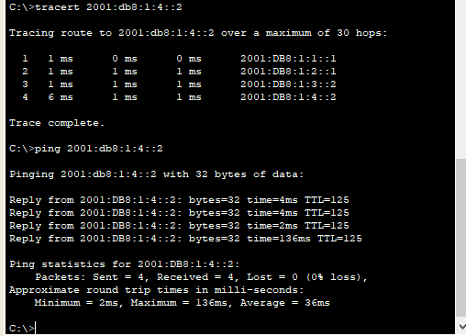
2. 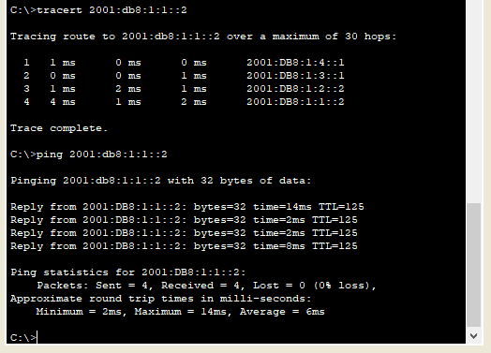

Step 6: